Cse370 Lab Assignment 01

Deadline: 19-06-2023 11:59 pm

Name: Ms Rodsy Tahmid

Id: 20101021

Sec-06

Task-1:

mysql -u root -p

create database Lab_HW1;

use Lab_HW1;

create table Developers

(

member_id int,

name varchar(30),

email varchar(30),

influence_count int,

Joining_date date,

multiplier int

);

insert into Developers values

(1, 'Taylor Otwell', 'otwell@laravel.com', 739360, '2020-6-10', 10),

(2, 'Ryan Dahl', 'ryan@nodejs.org', 633632, '2020-04-22', 10),

(3, 'Brendan Eich', 'eich@javascript.com', 939570, '2020-05-07', 8),

(5, 'Evan You', 'you@vuejs.org', 982630, '2020-06-11', 7),

(6, 'Rasmus Lerdorf', 'lerdorf@php.net', 937927, '2020-06-3', 8),

(7, 'Guido van Rossum', 'guido@python.org', 968827, '2020-07-18', 19),

(8, 'Adrian Holovaty', 'adrian@djangoproject.com', 570724, '2020-05-07', 5),

(9, 'Simon Willison', 'simon@djangoproject.com', 864615, '2020-04-30', 4),

(10, 'James Gosling', 'james@java.com', 719491, '2020-05-18', 5),

(11, 'Rod Johnson', 'rod@spring.io', 601744, '2020-05-18', 7),

(12, 'Satoshi Nakamoto', 'nakamoto@blockchain.com', 630488, '2020-05-10', 10);

Select * from Developers;

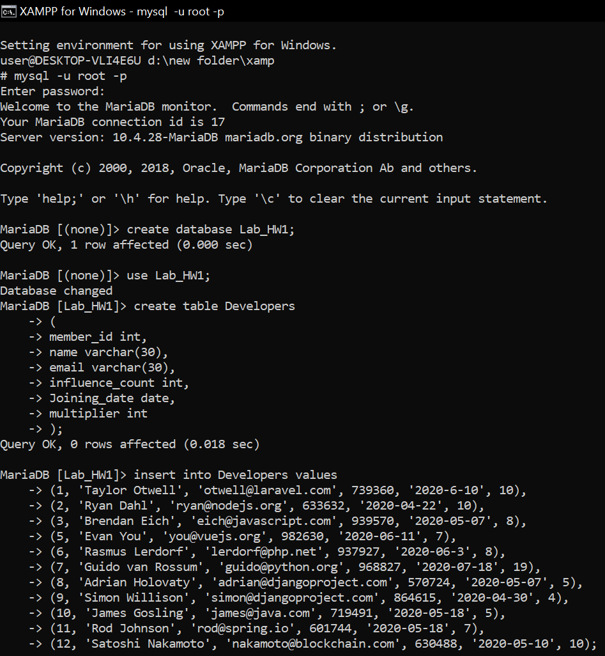

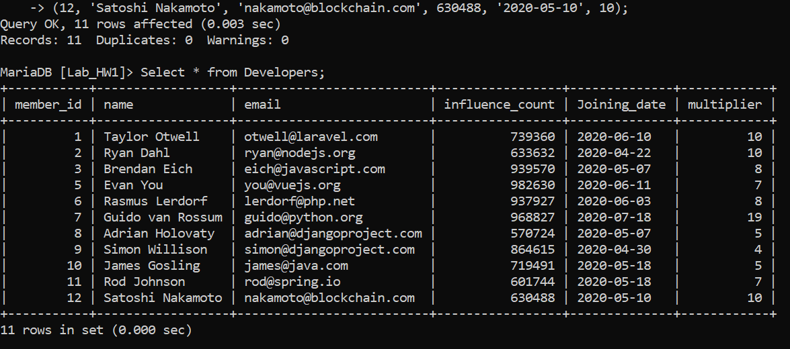

Task-2:

Alter table Developers change influence_count followers int;

Select * from Developers;

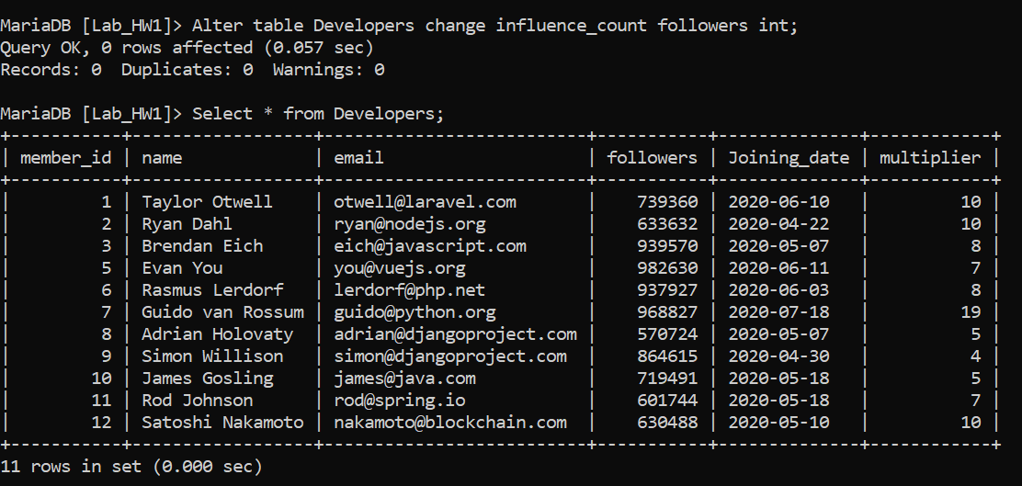

Task-3:

update Developers set followers = (followers + 10);

Select * from Developers;

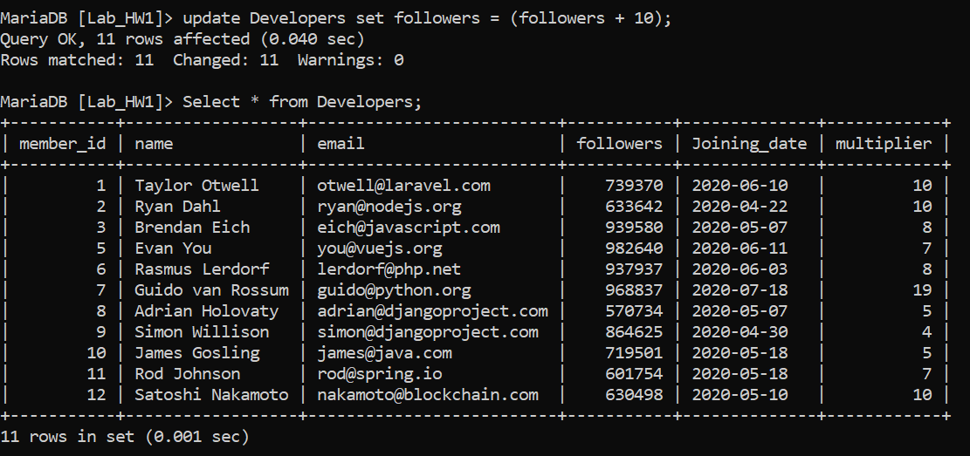

Task-4:

Select name, email, followers from Developers;

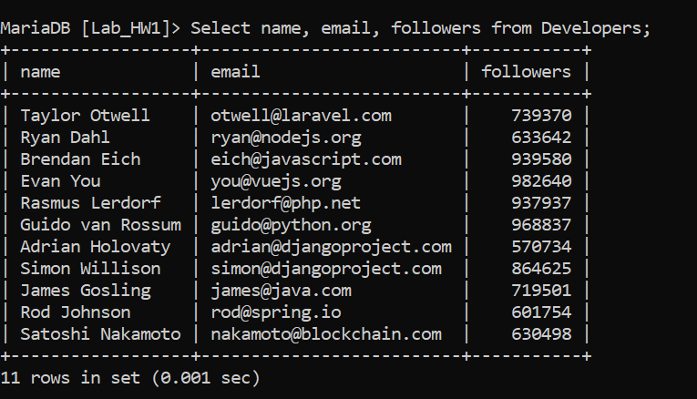

Task-5:

